Case Study: AI-Assisted UI Design
Through Visual Brainstorming
Date: 2026-06-17
Project: ROIS-AI Gantt — Legality Tab, Rule Parameter Table Editing
Session type: Design decision session using structured visual mockups

1. Introduction
This document is a case study on how to effectively use an AI assistant (Claude) to make UI design decisions for a non-trivial feature. The goal is not to show a finished product, but to document the process: how the session was structured, how design questions were framed, how visual options were presented, and how decisions were reached one at a time.

The Problem Being Solved
The ROIS-AI Gantt application has a Legality tab where aviation rule engineers view and manage rule parameter tables. These tables show rows of applicability conditions — columns like BASE, RANK, FLEET, TYPE, and ENABLE CHECK — that control how each rule fires during crew scheduling checks.
The tables were read-only. The user needed to add full editing capability:
- Modify rows in place (inline or dialog)
- Add new rows with format-aware validation
- Copy existing rows
- Delete rows with a double-confirmation step
- Reorder rows (move up / move down)
- Undo changes step by step back to the last saved state
- Column header tooltips describing each field
That is seven distinct UI behaviors. The session tackled them as a series of focused design decisions, each answered with a visual choice.

2. The AI Interaction Workflow
The session followed a deliberate five-phase structure.

Phase 1 — Explore the Codebase
Before any design work began, the AI read the actual source files. Key findings:
- The table renders parameter rows from the rule engine's param_json structure.
- The application has an established AppDialog standard (blue header, draggable, standard footer buttons).
- Some rules have 5–6 columns; others (like rule 8056) have 24 columns — both cases needed handling.
- There was no existing row-editing pattern to inherit; this was net-new.

Phase 2 — Frame Requirements as Separate Decisions
Seven requirements were broken into five independent design decisions:
- Decision 1: How should editing work?
- Decision 2: Where and when should row action icons appear?
- Decision 3: How should undo work?
- Decision 4: How should validation and the "Add Row" affordance look?
- Decision 5: How should delete confirmation work?

Phase 3 — Visual Companion: Three Options per Decision
For each decision, the AI generated an HTML mockup showing exactly three options — labeled A, B, C — rendered as realistic mini-previews with actual column names and UI states. The user selected from visual previews rather than reading textual descriptions.

Phase 4 — Collect Decisions into a Spec
Choices were assembled into a coherent design specification describing exactly what to build with no ambiguity about which option was chosen and why.

Phase 5 — Write an Implementation Plan
With a confirmed spec, the AI produced a phased implementation plan with dependency ordering, test checkpoints, and acceptance criteria for each phase.

3. The Five Design Decisions

Decision 1 — Edit Mode: How Should Editing Work?
When a user wants to modify a cell value in a parameter row, what is the editing experience?
Option A — Inline Cell Edit: The table row highlights yellow. Clicking any cell turns it into an input field right there in the table. A checkmark (confirm) and X (cancel) appear at the row's right end.
Option B — Expand-to-Edit Row: Clicking the edit icon causes the row to expand, revealing a form panel below it. The rest of the table remains visible above.
Option C — Dialog Popup: Clicking edit opens an AppDialog with a full labeled form. The background table fades. Uses the established dialog standard.
Mockup: Options A, B, C — Edit Mode
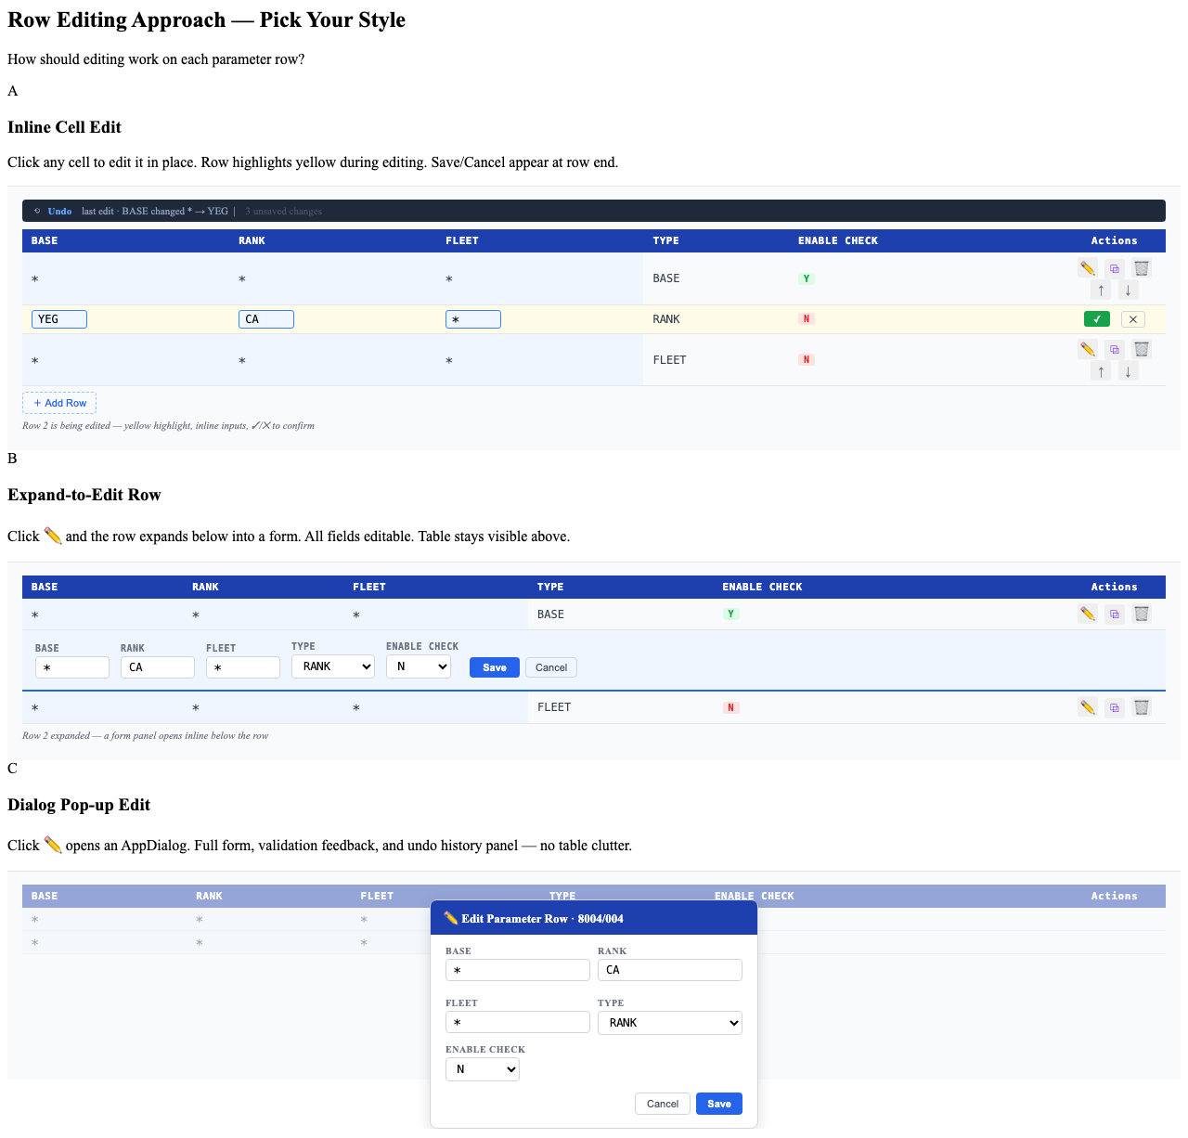
Decision: Hybrid — Option A for rules with ≤12 columns, Option C for rules with >12 columns.
Rationale: Inline editing (A) works well for compact rules. For wide rules like 8056 (24 columns), a dialog (C) is the right tool. The hybrid approach gives the best experience for both cases based on actual column count.

Decision 2 — Row Action Icons: Where and When Should They Appear?
The row actions are: edit, copy, delete, move up, move down — five icons per row.
Option A — Always Visible, Right Column: A permanent "Actions" column at the right of every row. All five icons always visible. ~110px column width.
Option B — Hover-Reveal Icons: Actions are hidden until the user hovers over a row — the row gets a tint and icons fade in. Keeps the table visually clean.
Option C — Drag Handle Left + Three Icons Right: A drag handle (⠿) at the left replaces up/down arrows. Only edit, copy, delete on the right. More natural reordering, but adds implementation complexity.
Mockup: Options A, B, C — Row Action Icons
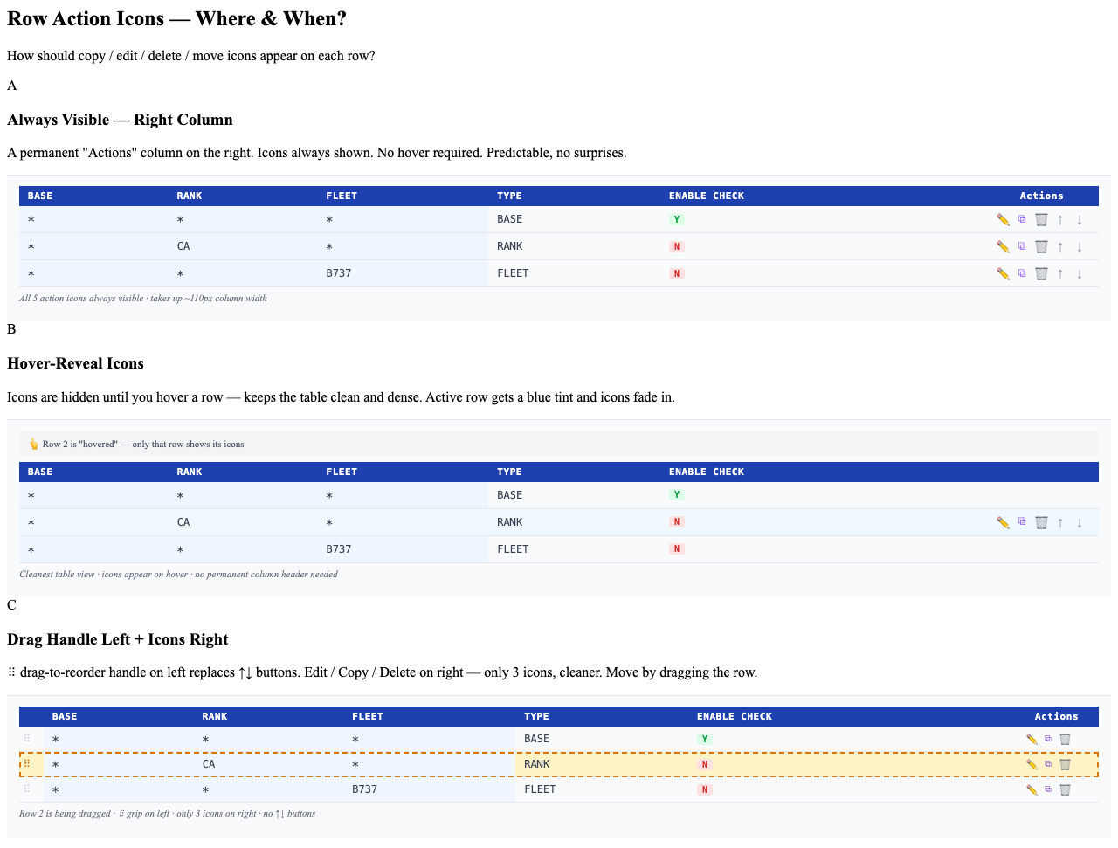
Decision: Option A — Always visible right column.
Rationale: For an operations interface used by rule engineers scanning and modifying data systematically, discoverability matters more than visual density. Hover-reveal (B) hides functionality. Drag (C) introduces a new interaction paradigm that requires training.

Decision 3 — Undo Feature: How Should It Look?
Users need to undo edits, deletions, and additions step by step, back to the last saved state.
Option A — Toast Undo Bar: A dark notification bar after each action with an "Undo" link and countdown timer. Auto-dismisses after 8 seconds. Limited to one undo step.
Option B — Toolbar with History Dropdown: A persistent toolbar above the table with Undo/Redo buttons, an unsaved-changes count badge, and a dropdown showing full history.
Option C — Side Change Log Panel: A panel docked to the right. Every change appears as a color-tagged log entry — EDIT (blue), DEL (red), ADD (green). "⟲ Undo" steps back. "Save All" commits.
Mockup: Options A, B, C — Undo Design
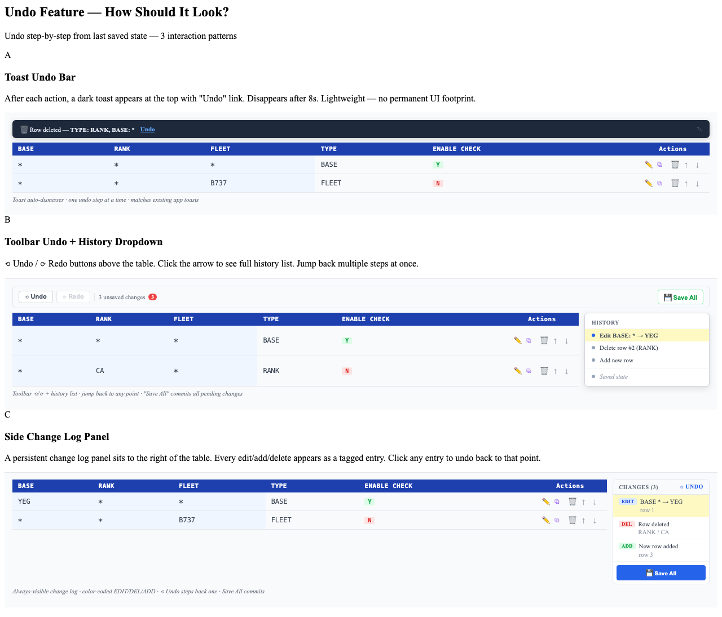
Decision: Option C — Side change log panel.
Rationale: Rule parameter editing sessions tend to involve multiple sequential changes. The toast (A) is too ephemeral. The side panel (C) keeps the full change history persistently visible while editing, matching the workflow of an engineer carefully adjusting parameters.

Decision 4 — Validation and Add Row: How Should Cell Errors Look?
When a new row is added all cells are empty (required). When a time field receives a non-time value, the format must be enforced.
Option A — Red Ring + Inline Error Hint: Empty cells: 2px solid red border + light red background. Format errors: orange border. Small message ("Required" / "Use HH:MM") below the cell. Add Row is a dashed ghost button.
Option B — Soft Red Fill + Error Icon: Soft pink background for empty cells. Yellow/amber background with ⚠ icon for format errors. Add Row is a solid blue filled button.
Option C — Dashed Border + Error Badge + Ghost Row: Dashed red border for empty cells. Solid red border + "ERR" badge for format errors. Add Row is a ghost table row at the bottom.
Mockup: Options A, B, C — Validation & Add Row
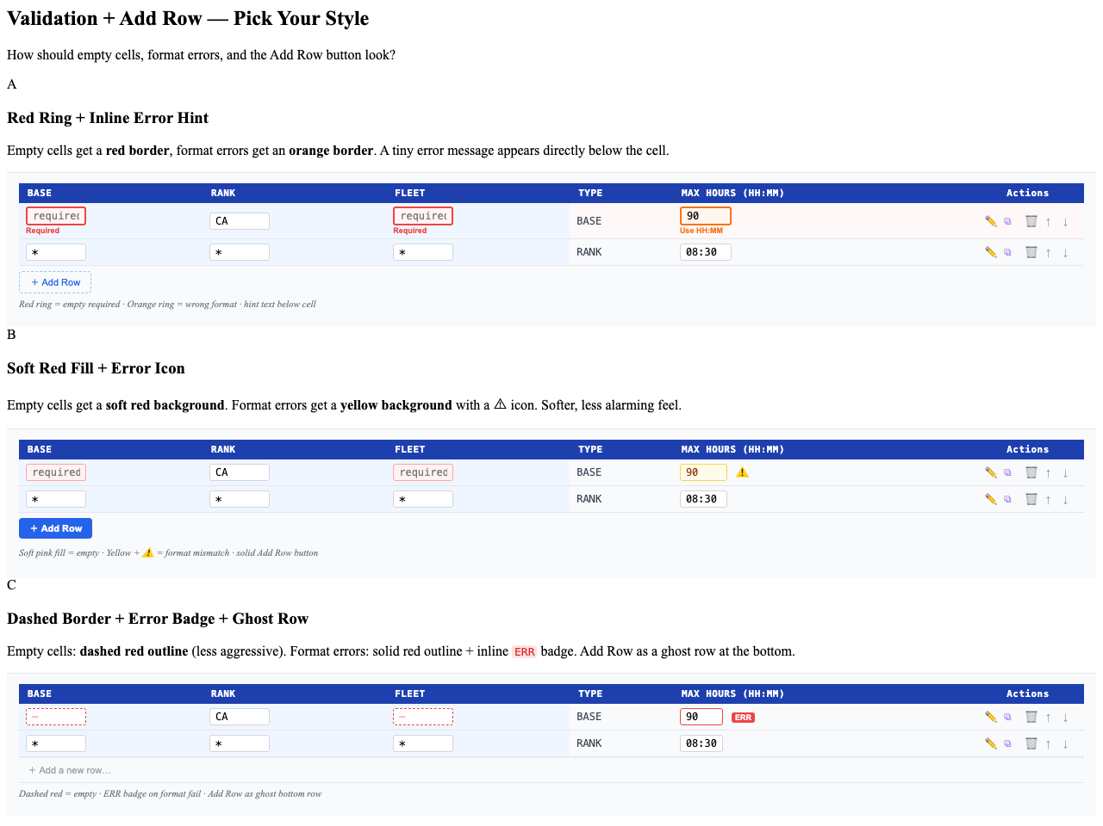
Decision: Option A — Red ring + inline error hint.
Rationale: Solid red for missing values and orange for format errors provides a clear two-level signal. The inline hint text tells the user exactly what to do. In a dense parameter table, explicit ring outlines are easier to scan than soft fills.

Decision 5 — Delete Confirmation: Which Double-Confirm Style?
Deleting a parameter row is a significant action that should require explicit confirmation.
Option A — Inline Row Confirmation: The row turns red. Action icons are replaced by "Delete?" label, a red "Yes, delete" button, and a "Cancel" button. No popup — confirmation happens right in the row.
Option B — Popover Near the Delete Button: A small popover card anchored to the delete icon shows the row's key details and Cancel / Delete buttons. Row appearance unchanged.
Option C — AppDialog Modal: A full AppDialog with red header "Delete Row", a summary of the row being deleted, and Cancel / Delete in the footer. Background table dimmed.
Mockup: Options A, B, C — Delete Confirmation
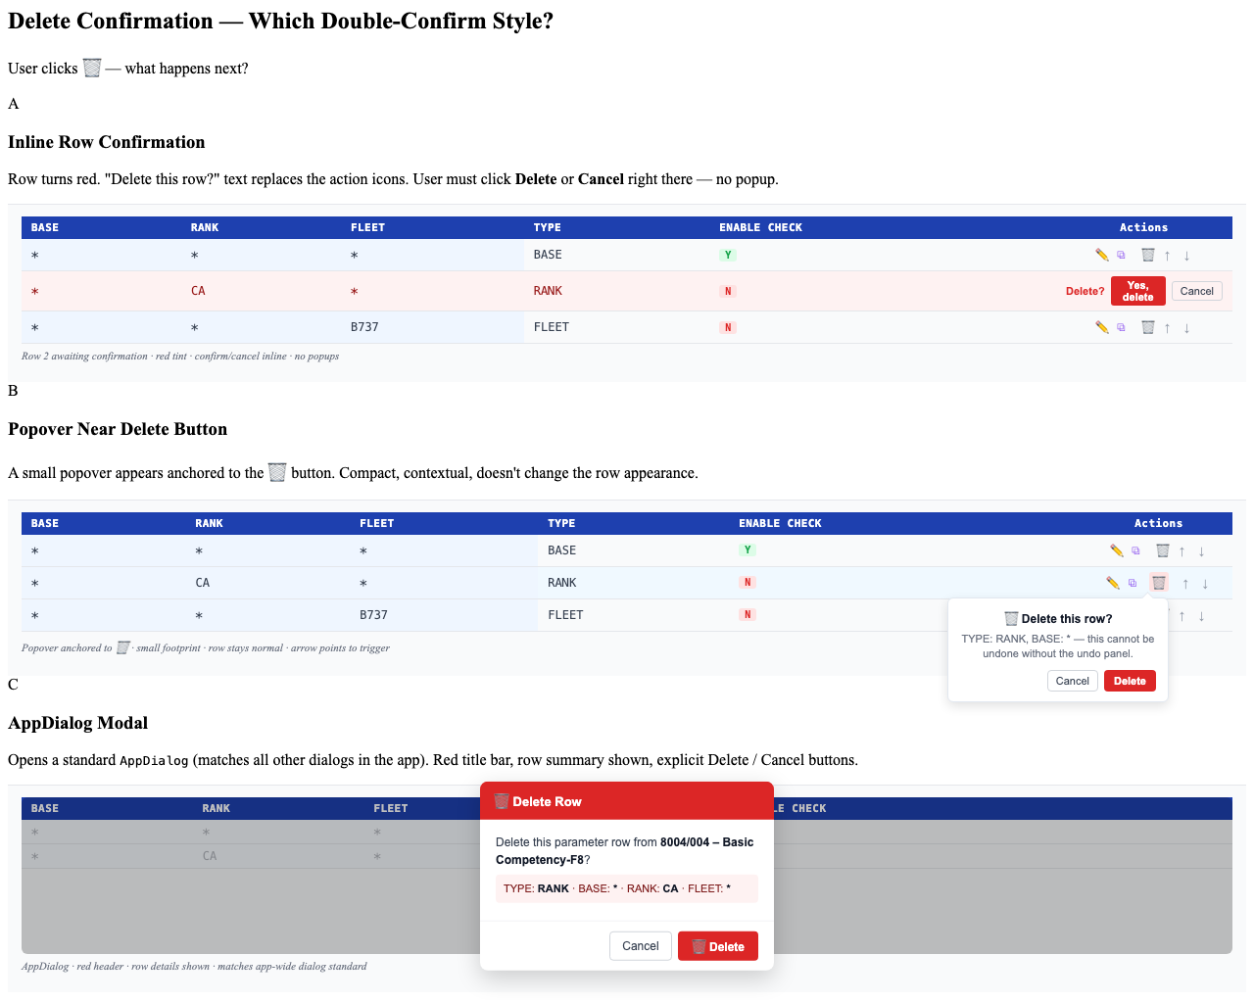
Decision: Option A — Inline row confirmation.
Rationale: Inline confirmation keeps the user's attention on the data they are about to delete. No context-switching. The AppDialog (C) would be appropriate for deleting a whole ruleset but is over-engineering for a single parameter row.

4. Final Design Decisions Summary
Area | Decision
Edit mode — narrow rules (≤12 cols) | Inline cell edit — row highlights yellow, inputs in place, ✓ / ✕ at row end
Edit mode — wide rules (>12 cols) | AppDialog popup — full labeled form, matches app dialog standard
Action icons placement | Always visible "Actions" column — edit ✏ copy ⧉ delete 🗑 move ↑ ↓
Undo / change history | Side change log panel — EDIT/DEL/ADD color tags, ⟲ Undo, Save All
Empty cell validation | Red ring outline + "Required" hint text
Format validation (e.g. HH:MM) | Orange ring outline + "Use HH:MM" hint text
Add Row affordance | Dashed ghost button below table — "+ Add Row"
Delete confirmation | Inline — row turns red, icons replaced by "Delete? / Yes, delete / Cancel"
Column header help | Hover tooltip on each column header

5. Key Takeaways: How to Use AI for UI Design
1. Explore the codebase before designing.
The most useful thing the AI did before presenting any options was to read the actual source files. This grounded the design in reality — it knew the AppDialog standard, that some rules had 24 columns, that there was no existing row-edit pattern. Generic UI advice is easy to give; advice rooted in the specific codebase is much harder to get elsewhere.
2. Break the feature into independent decisions.
Seven requirements sounds like one design problem. It is actually five or more independent design choices. Breaking them apart explicitly prevents one decision from bleeding into another and makes the session faster, not slower.
3. Present exactly three options, rendered visually.
Describing options in text forces the reader to build mental images and compare them in working memory. Showing three rendered HTML mockups collapses that cognitive work. Three is the right number — two feels like a binary; four or more is too much to hold in comparison at once.
4. Ask one question at a time.
Each decision was its own message exchange: present three options, get an answer, move to the next. This keeps the user's cognitive load bounded to one question at any moment.
5. Capture rationale, not just the choice.
For each decision, the answer included a brief reason. These reasons prevent misinterpretation in later phases and seed the spec with design intent — helping anyone reading it later understand why things are the way they are.
6. Build up to a spec, then a plan.
The design session produced a specification first — a single, unambiguous description of what to build. Only after the spec was confirmed did the session produce a phased implementation plan. Specs answer "what and why". Plans answer "how and in what order". Mixing them causes both to suffer.
7. Visual mockups do not have to be polished.
The five HTML mockups were functional but deliberately minimal: monospace table cells, a few color classes, emoji icons. They took minutes to generate. Their purpose was to be visually distinct enough that the user could tell options A, B, and C apart without reading the description twice.

6. Artifacts from This Session
Artifact | Location
Edit mode mockup | .superpowers/brainstorm/…/row-editing-approach.html
Row actions placement mockup | .superpowers/brainstorm/…/row-actions-placement.html
Undo design mockup | .superpowers/brainstorm/…/undo-design.html
Validation + Add Row mockup | .superpowers/brainstorm/…/validation-addrow.html
Delete confirmation mockup | .superpowers/brainstorm/…/delete-confirm.html
Design spec | docs/superpowers/specs/2026-06-17-legality-param-table-editor-design.md
Implementation plan | docs/superpowers/plans/2026-06-17-legality-param-table-editor.md
This case study | docs/dev-context/2026-06-17-ai-ui-design-case-study.docx

